Project Design Phase-II
Data Flow Diagram & User Stories

Date | 30 September 2026
Team ID | Team 7
Project Name | Streamlining IT Procurement: Automating Standard Laptop Orders with Flow Designer
Maximum Marks | 4 Marks

Data Flow Diagrams:
A Data Flow Diagram (DFD) is a traditional visual representation of the information flows within a system. A neat and clear DFD can depict the right amount of the system requirement graphically. It shows how data enters and leaves the system, what changes the information, and where data is stored.
DFD Level 0 (Context Diagram):
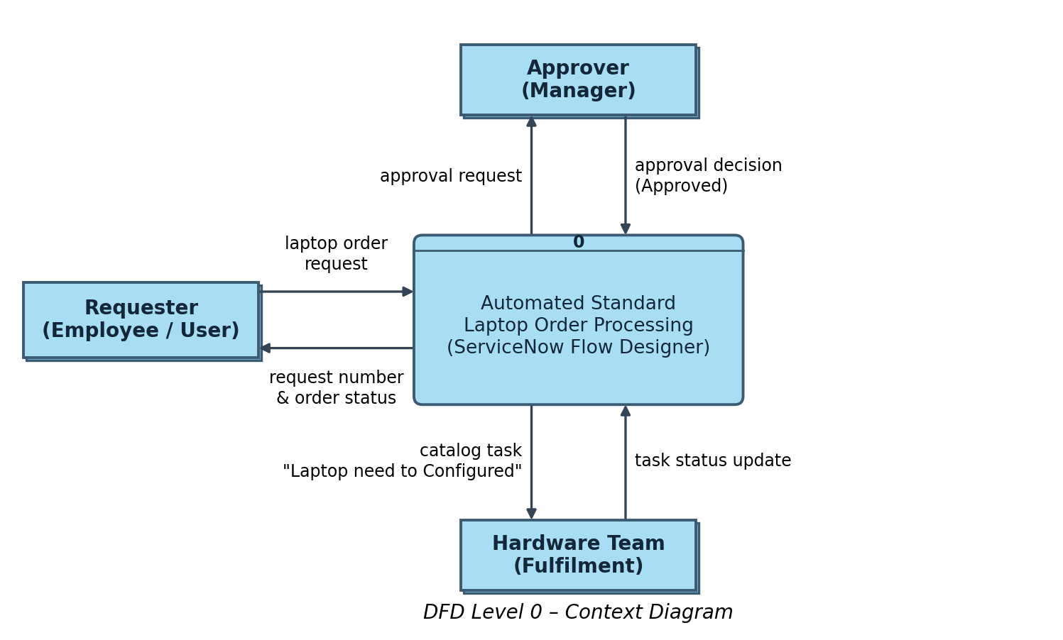
DFD Level 1:
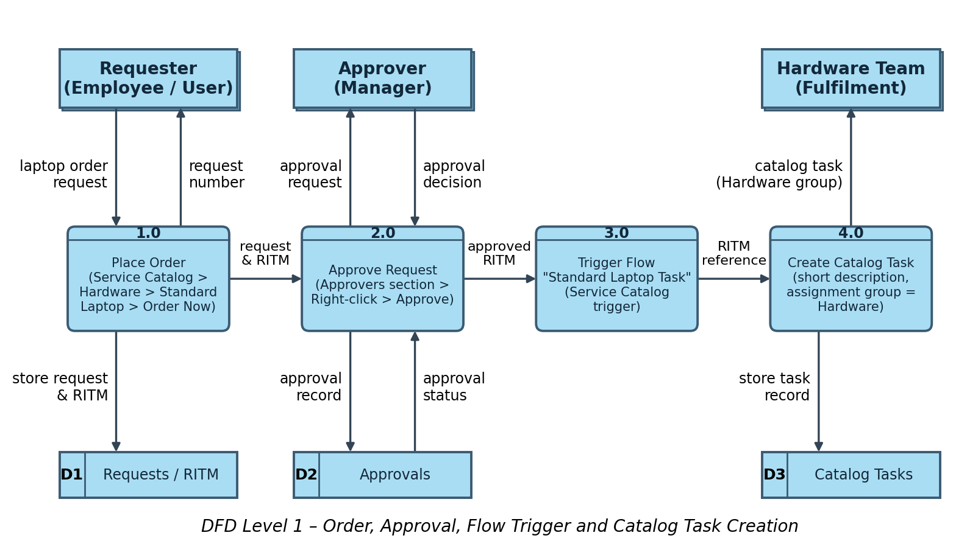

User Stories
Use the below template to list all the user stories for the product.
User Type | Functional Requirement (Epic) | User Story Number | User Story / Task | Acceptance criteria | Priority | Release
Requester (Employee) | Order Standard Laptop | USN-1 | As a requester, I can open the Service Catalog, go to Hardware, select "Standard Laptop" and click "Order Now" to place a laptop request. | A request is created and its Request Number is displayed in the order status | High | Sprint-1
 |  | USN-2 | As a requester, I can open my Request Number to track the status of my laptop order. | I can open the request record and see the approval and requested item details | Medium | Sprint-2
Approver (Manager) | Approval | USN-3 | As an approver, I can see the pending approval in the Approvers section of the request record. | The approval record is listed with its state as Requested | High | Sprint-2
 |  | USN-4 | As an approver, I can approve the laptop request by right-clicking the approval record and selecting Approve. | Approval state changes to Approved and the requested item moves ahead for fulfilment | High | Sprint-2
IT Procurement Team (Flow Administrator) | Flow Creation | USN-5 | As an administrator, I can create a flow named "Standard laptop task" in Flow Designer (Application: Global, Run as: System user). | The flow is created and saved under Flow Designer | High | Sprint-1
 |  | USN-6 | As an administrator, I can add a Service Catalog trigger to the flow so that it starts whenever a standard laptop is requested. | The flow triggers automatically when the catalog item is ordered | High | Sprint-1
 | Catalog Task Automation | USN-7 | As an administrator, I can add the "Create Catalog Task" action with the Requested Item record, short description "Laptop need to Configured", Assignment group "Hardware" and Approval "Approved". | A catalog task is created automatically with the correct short description and assignment group | High | Sprint-1
 |  | USN-8 | As an administrator, I can save and activate the flow. | The flow status shows Active | High | Sprint-1
 | Flow Assignment | USN-9 | As an administrator, I can attach the "Standard Laptop Task" flow to the Standard Laptop catalog item under Maintain Items > Process Engine, removing other automations. | The Standard Laptop item runs only the assigned flow when ordered | High | Sprint-2
Hardware Team Member | Laptop Configuration | USN-10 | As a hardware team member, I receive the catalog task automatically in the Hardware assignment group, so the laptop can be configured promptly on arrival. | The catalog task appears under Catalog Tasks of the requested item with the short description and Hardware assignment group | High | Sprint-3
 |  | USN-11 | As a hardware team member, I can open the catalog task and view its updated status to confirm the laptop configuration. | The catalog task record shows the updated status and assigned group | Medium | Sprint-3

